Sample Syllabus - with institution-specific boilerplate removed

DRA 101 Drawing 1 Fall 2017 Marcus Greene

Course Description
Drawing 1 is an introductory course focused on developing observational and conceptualizing skills, needed to create drawings that are both accurate and expressive. The course will explore traditional drawing issues, materials, and techniques, as they are applied to a variety of contexts, including still life, portraiture, landscape, interior space and limited imaginative contexts. Emphasis is given to exploring different media and technical applications, in tandem with observational and investigational skills. The technical elements addressed will include- line quality, structure, proportion, perspective, and modeling form in space with values of light and shadow.

Goals
The goal of Drawing 1 is to give students the skills to see well, and to respond with images that are accurate and interesting. The course also develops the verbal as well as visual vocabularies needed to better understand their own personal aesthetics, and to interpret others, especially as they relate to the art making process.

Learning Objectives: After completing this course, students are expected to be able to:

- Demonstrate an understanding of the physical differences and appropriate selection of traditional drawing media.
- Deal with the simpler methods of mark making and manipulation.
- Make informed selections of materials including paper.
- Deal with issues of image development through preliminary studies to finished drawings.
- Show an appropriate growth of expertise with traditional drawing materials.
- Understand the variety of line and mark vocabulary and their ability to construct images.
- Demonstrate understanding of how basic structures of light and shadow reveal volumetric form.
- Demonstrate some variety of rendered image, both additive and reductive.
- Show a basic ability to create the illusion of space in one and two point perspective.
- Demonstrate understanding of the role of edges, contrast, and “atmospheric perspective” in creating an illusion of space.
- Develop an understanding of the importance of keeping a daily sketchbook as a personal conversation.
- Present finished work in a proper, professional manner.
- Complete all assignments successfully; pushing your creative abilities to their limit, without reliance on stereotypic solutions.
- Keep abreast of your progress and development and communicate with me whenever you need more input and or support.
- By class participation, group critiques, individual discussion, etc. demonstrate an awareness of sensibility and quality of your class’ finished work.
- On a level appropriate to your development and experience, verbalize and build a vocabulary sufficient to discuss and defend your work, and the work of your colleagues, beyond simple technical concerns.Begin to build an awareness of historic and on-going contexts for drawing by becoming familiar with a range of past and present masters.

PREREQUISITES- none

TEXT None required, but there are recommended references to Mendelowitz and Wakeman, A Guide to Drawing.

MATERIALS FOR CLASS:
Drawing Tools:
Drawing Board with clips approx. 23 ½ “ x 26”
Graphite pencils (HB, 2B,4B, 6B) set
Soft Vine charcoal Willow Charcoal, jumbo sticks
Compressed Charcoal, primarily soft
Charcoal pencils: white and black (2B, 4B, 6B)
Conte pencil: black, white, sanguine
Erasers: pink pearl, STAEDTLER Mars Plastic, gray kneaded eraser
India ink, bamboo brush, quill pen, microns or other similar

Paper: Newsprint Pad 18x24
Strathmore Heavyweight Drawing pad 18 x 24
Sketchbook size 9” x 12” or 11” x 14”
Larger paper as needed

Standard supplies:
Metal ruler, minimum 18”
Utility knife ( with extra blades)
Cheap masking tape
Workable spray fixative
Tool box or carrying case for supplies
Portfolio (22” x28” or larger)with handles to protect work
You can use a paper or plastic portfolio with reinforcement & handles or make a handmade portfolio with cardboard or foam core (duct tape seams, clips to fasten)

RESEARCH WORKBOOK- Traditionally artists have maintained workbooks to search out preliminary ideas for the art making process. For the purposes of all Foundations courses each student must maintain a carefully considered sketchbook that contains sketches and thumbnails for each classroom project and each homework project.

EVALUATION- Students will maintain a portfolio of class and homework. Assignments are due as specified on the syllabus and will be late thereafter. Work will be reviewed each week. Class work will account for 60% of the grade, homework- 35%. Attendance, punctuality, attitude, class participation are considered as deciding factors in grades 5% . Failure to bring prescribed materials on specified days is equivalent to absence. Students who miss more than 3 of 30 class sessions are subject to automatic failure

Class Etiquette
Keep the studio neat and safe at all times. This means cleaning up at the end of each class and paying attention to your materials. Respect fellow students & others’ work in this studio since we share the same room with many classes. We are short on storage and need to be especially considerate of each other and classmate’s work..
Arrive on time, make good use of the full class period to work, draw, plan, and go further than merely satisfying requirements.
Clean up after yourself. Wipe desks. Never use mat cutters or exacto knives on tables
without first protecting the surface with a heavy cardboard backing or similar surface.
Never pour paint down the drain, You can salvage most of your paint after a class session.
Throw all paint soiled towels into the red metal cans by the sink. No food is allowed in the classroom, beverages are allowed but must have a cover.
Please keep excessive noise and talking to a minimum- so that others may work deeply.

Electronic Media
Cellphones are to be turned off prior to the beginning of class.
Please keep cell phone use to emergencies only (notify me) and class break. Headsets are not allowed. Electronic media is prohibited during lectures, critiques, presentations and demonstrations. Limited use of personal music devices is a privilege to be requested and granted on occasion, at the discretion of the instructor.
DRA101 INTRODUCTION TO DRAWING Marcus Greene CALENDAR

1 Introduction to Course, Supplies
history and function of drawing
in civilization
in your life
media exploration: graphite, charcoal, ink, papers, erasers

2 Concentration and Line Quality
blind and modified blind contour drawing
upside down and inverted drawing
visual analogs - line quality:
intuition, speed, pressure, rhythm, texture

reference: Matisse, Schiele, Picasso, Hockney, Delacroix, Rembrandt, Shahn

home: Read chapter 5
1st project: consider line quality AND composition- scale, overlap etc.
Three 18x24”drawing pad pages filled with groups of line drawings of a single repeated organic object: shoe, bug, flower, etc.-1 page graphite, 1 page charcoal, and 1 page ink pen and/or brush; due class 4

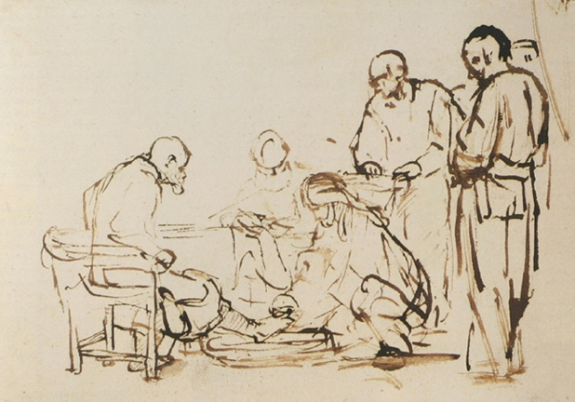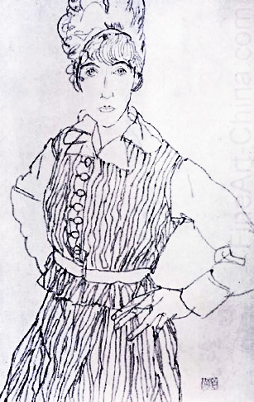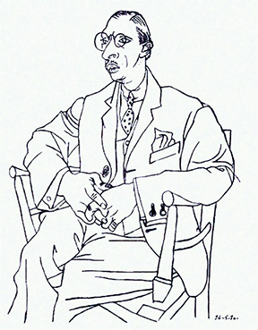
Rembrandt Schiele Picasso

3 Continue Line Quality and Begin Sighting greene
table-top still life- intuitive and sighted perspective

home: chapter 14
2nd project: Figure, 3 self-portraits all using line (without shading), but with 3 different media & different expressive line qualities (i.e. fine, smooth, fluid, and continuous vs heavy, choppy, erratic); due class 5

4 Mapping and Relational / Structural Drawing BASIC SHAPES
sight measuring- large shapes first
viewfinders- positive / negative shapes, figure / ground
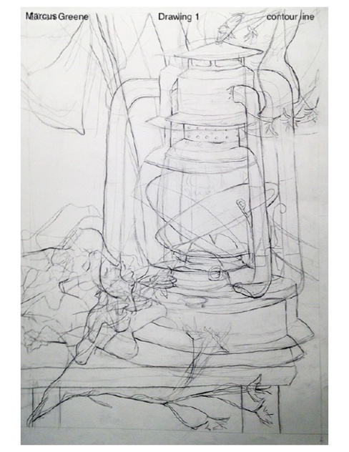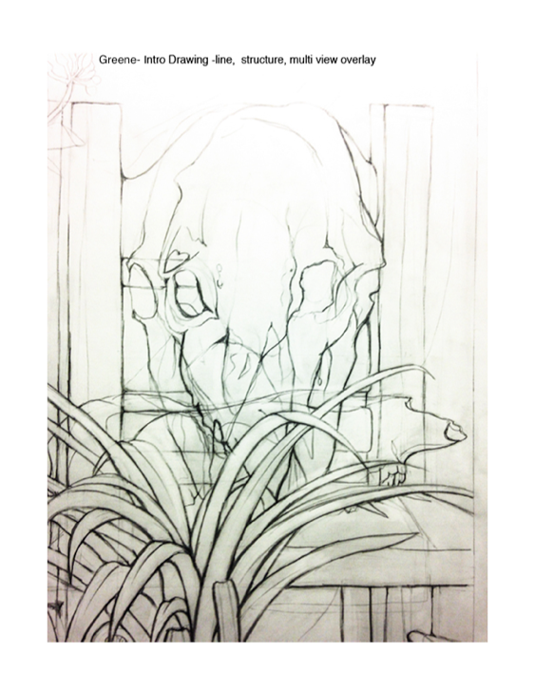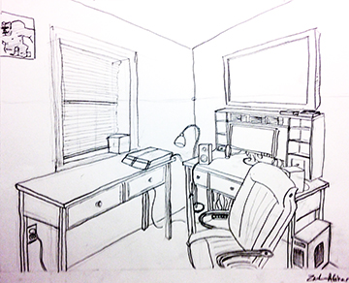
Student- linear / structure Student- linear / structure Student- sighted room

5 Mapping / Structural Drawing TOYS
cross contour, axis ellipses
planar reduction, geometric & organic

home: 3RD project: interior, corner of room emphasizing perspective
sighted with viewfinder due class 7
gestural ref: Kollwitz, Rembrandt, Degas, Hokusai, Lebrun
structural ref: Giacometti, Cambiaso, Lomazzo, Moore

6 Mapping / Structural Drawing continued TOYS

home 4th project: hands and feet structural drawing, due class 9

Drawing 1 Greene

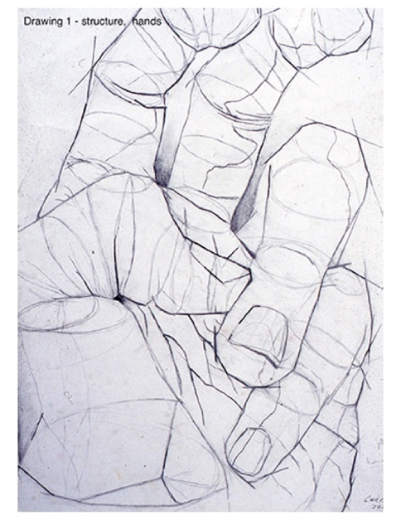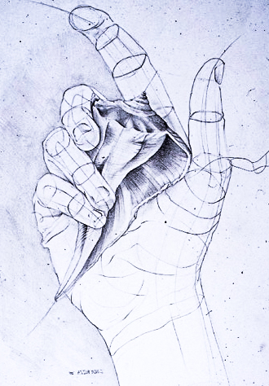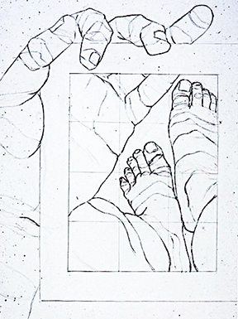 Student- structural hand Student- structural hand Student- viewfinder

7 Value, Form, and Space- still life- geometric volumes
light and value revealing form
mark making and structure directional marks & hatching contrast and space (atmospheric perspective)

home 5th project: 3 thumbnail sketches and 1 “finished” still life, due class 11

8 Value, Form, and Space Continue / finish geometric volumes

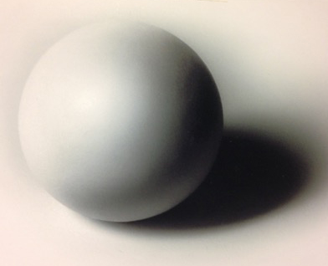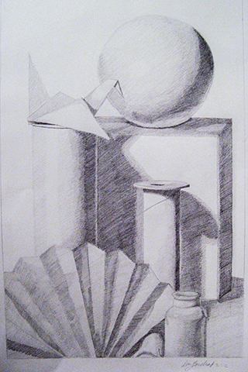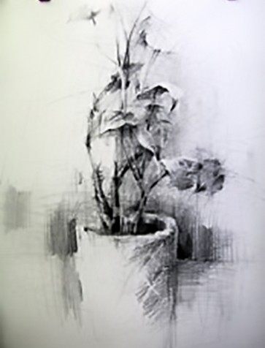

Drawing 1 Greene

9 Gray Paper Value / Chiaroscuro / Markmaking
gray paper with white highlighting
reflective (glass and metal) still life
structured mark-making / hatching

home 6th project: chiaroscuro (self) portrait (w/ white highlights),
thumbnails due class 11 finished project due class 13

reference: Pierre-Paul Prud’hon, Paul Cadmus, Anthony Ryder

10 Gray Paper Chiaroscuro Still Life continue / finish

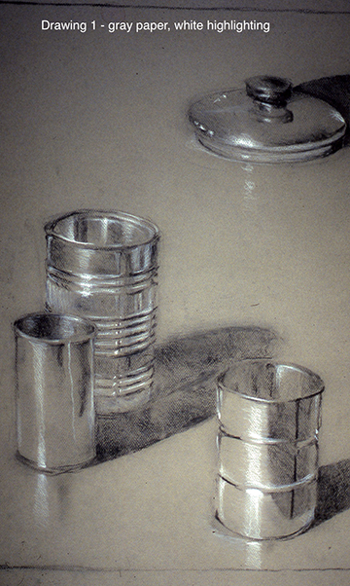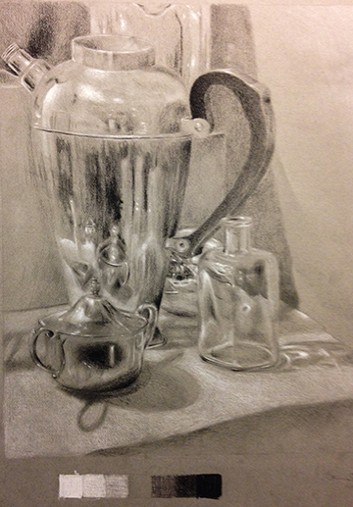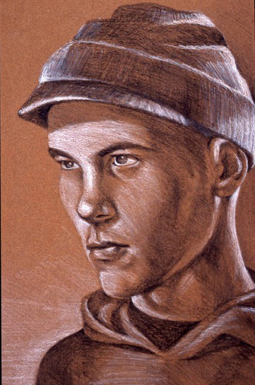Student- gray paper Student- gray paper Student- gray paper

11 7th Project Large Master Copy (photographed sculpture)

reference: Moore, Giacometti, Kapoor, Neri, Yoruba, etc.

12 Large Master Copy (photographed sculpture) continued / finish

Drawing 1 Greene
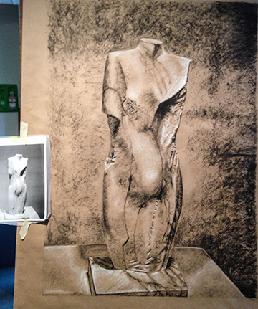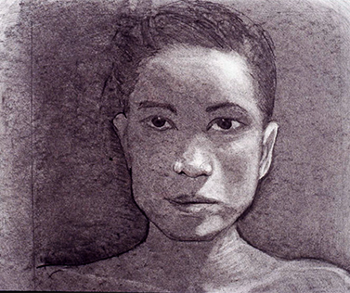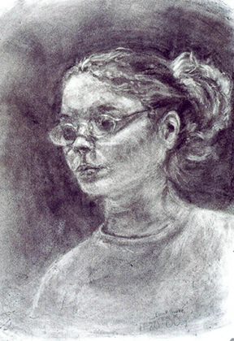
Student – large scale master copy Student- Subtraction Student- Subtraction

13 Subtractive Process- Reflective Still Life

reference: Jim Dine, Michael Mazur
home 8th project: subtractive (self) portrait, due class 15

14 Subtractive – Reflective Still Life continue / finish

MIDTERM submit portfolio containing:
Initial class, line quality exercises
projects 1 3 pages of organic objects
“ 2 3 Linear self-portrait drawings
Class, drawing, positive/negative space
Class “toy” still lives
“ 3 Interior corner, sighted perspective
Mapping and Structure classwork
4 Structural hand and foot drawings
“ 5 3 sketches, and finished value/form/hatching still life
Reflective still lives
6 Chiaroscuro self- portrait
“ 7 Large Master copy

Drawing 1 Greene

15 Ink Pen / Ink Wash- Media Exploration various applications- still life
stipple sighting organic object
hatching structure geometric objects
ink wash and gesture space- interior, exterior

reference: Rembrandt, Kanevsky, Steadman

home 9th project: wash (self) portrait, due class 21

16 Ink Pen / Ink Wash- Media Exploration various applications- still life

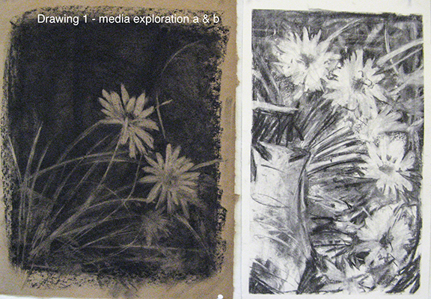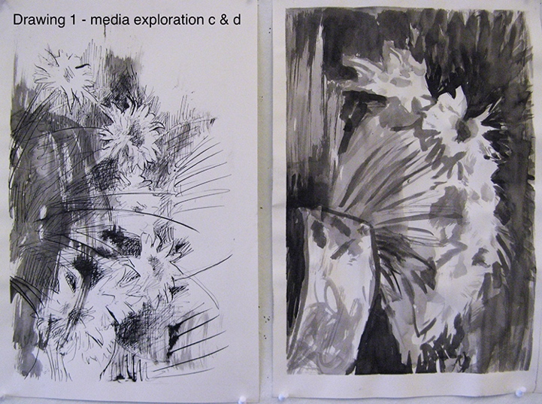
Student- Media Exploration Student- Media Exploration

17 Representing Space- Linear and Atmospheric Perspective,
historic and archetypal systems for representing 3 dimensional space two dimensionally :
stacked perspective- cave art, Egyptian Art
isometric- Asian Art, architectural drawings, games
Renaissance- 1 point and 2 point
atmospheric perspective

home and classwork: 10th project, good perspective-oriented sketches from life, indicating approximate horizon lines and (as appropriate) vanishing points, 2 one-point perspectives, and 2 two-point perspectives: due class 25

18 Perspective Linear and Atmospheric Perspective continue / finish
practice 1 point and 2 point
“play” with 3 point

Drawing 1 Greene

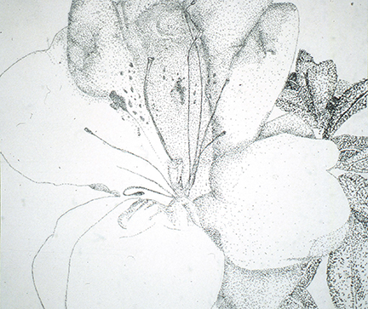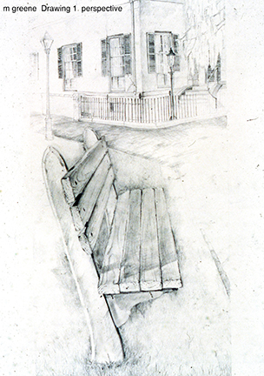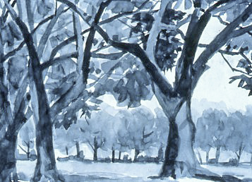
Student- stipple 1 and 2 pt Perspective Student- Landscape, Ink Wash

19 Landscape Project - Mixed - Wet and Dry Media
texture, pattern, and mark making, abstraction

home: 11th project- landscape, ch.13, due class 21,
a. organic object study stipple or cross-hatching
b. sketches for landscape (values)
c. landscape (13.3)

20 Landscape Project - Mixed - Wet and Dry Media

21-25 12th Project Abstraction - Microcosmic Still life

Home and Classwork:
Full size drawing:
Stencil Studies- 6 small sketches- options of circular, square, traditional or panoramic rectangle
explore options of scale and cropping

Drawing 1 Greene

Project 12- Refine new “abstracted” (micro-) composition

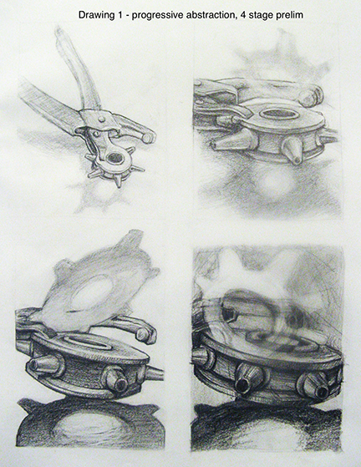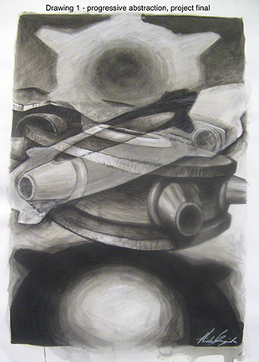
Student- Abstraction Studies Abstraction Final

27-28 13th project Independent Research and Exploration
submit FINAL portfolio containing:
8 (subtractive) self portrait project
media exploration
Ink Wash self
9 (ink/wash) portrait project
10 perspective
11 landscape with sketcehs
12 FINAL Abstraction PROJECT with micro studies
13 independent Project

29/30 FINAL CRITIQUE and CLASS WRAP UP

