Sample Syllabus - with institution-specific boilerplate removed

Figure Drawing 2 DRA 202A Marcus Greene

Course Description:
This course builds on concepts and techniques explored in Figure Drawing I. Students will negotiate the challenge of continued structural and anatomical accuracy while introducing more expressive approaches with respect to mark making, color, scale, mixed media, sequence and series. Multi-figure, narrative, and more abstract possibilities will be explored.

Course Goals:
1) The formal elements of the figure will be explored in terms of gesture, structure, anatomy, and volume.
2) Traditional and contemporary issues of content-concept, expression and narrative, will also be addressed.
3) Assignments are given to further enrich students’ understanding of the concepts presented, towards the goals of creating figurative works using traditional and contemporary approaches. We’ll move from smaller, black and white images to larger studies, and from smaller limited palette works to broader palette with greater complexity in mark making, space, and narrative concepts.

Skills, Techniques, and Materials:
- Students explore the formal elements used to describe the human form through alive, alert, and responsive approaches.
- Students study and demonstrate an understanding of the key, underlying anatomical landmarks in the skeletal structure and musculature of the body, demonstrating effective methods of constructing the human form.
- Students grow in their abilities to problem solve, composing, gathering visual information, and developing a drawing.
- Pencil, charcoal, conte, pastel, water based media as well as mixed media will be explored using a variety of papers including BFK, Stonehenge, Canson, and Arches
- Model set ups and self portrait assignments are the primary sources of study with master copies supporting the understanding of techniques.
- We will discuss your work in process and in the final stages to further develop analytical and critical skills. Journal entries of your work in progress as well as critical evaluations of work you see, supports this process.

Course Mechanics:
1) Meet twice a week for 3 hours each.
2) Employ models, uses casts, easels, appropriate lighting, model stand, props etc.
3) Generally requires 6 hours of homework weekly.
4) Instructional methodology: We discuss techniques and media, learning from examples of drawing in printed, power point, and pinned form.

Student Responsibilities:
- Keep an active journal with required and self-propelled written and drawn entries including anatomical studies, gestures, copies after masters, drawings from life, preparatory drawings for narrative series, and self-critiques. These journals should be full of exploration, ideas, questions, critiques etc… make them engaging!
- Keep work signed and dated in portfolios
- Participate in class discussion and critique
- Commit to all assignments and turn in work on time. I understand fall backs due to sickness or uncontrollable circumstances but will need notes and follow up for such occasions, talk with me so we understand there’s a plan of action underway.
- Set specific goals and work with intuition, practical problem solving, inspiration and good, old hard work!

Suggested Texts:
Drawing From Life, Brown/McLean ISBN# 0534613535
Anatomy for the Artist, Metro Books, Jeno Barcsay, ISBN# 1-58663-174-8)
Figure Drawing, Nathan Goldstein, Pearson Publishing ISBN# 10 –0-13-603191-9
Drawing Human Anatomy, Giovanni Civardi
Atlas of Human Anatomy for the Artist, Stephen Rogers Peck, Oxford University Press ISBN# 978-0-19-503095-2

Figure Drawing 2 DRA 202A Marcus Greene

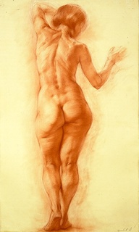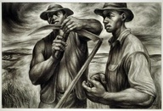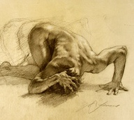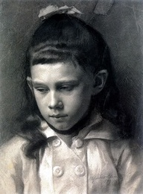
Mikhail Khozinsky Charles White Robert Liberace Gustav Klimt

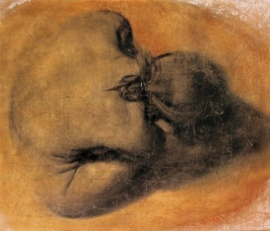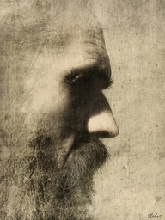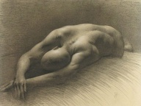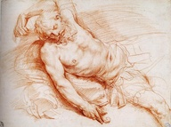

Maurizio Bonfanti Vladas Orze Juliette Aristides Giuseppe Cesari

Week 1:
Introduction. Gesture. (pen, charcoal, crayons, markers) (line variations, structural aspects of the human form, understanding of proportional, architectural and gestural analysis, and development of familiarity with skeletal and muscular anatomy.) Quick, loose, “felt”- establishment of relationship between multiple figurative structures on one page. Importance of understanding the spinal column, skull and pelvis, and the abstract interactions of these masses on the page. Introduction to the course: syllabus, policies, and supply list, slide presentation. Work from the model.

Homework Assignment:
1) Buy materials, make journal or add papers to one, work full length skeletal studies, front, back, and side, along with one (finished drawing) 18 x 24" lit skeletal study (use the classroom skeleton) Due 2/6

2) A black and white self-portrait head or more on “good” paper (Stonehenge, Arches, Rives, Canson), can be gessoed, toned, etc., singular or mixed media using modeling techniques (hatching, cross-contour hatching, subtractive, smearing and highlighting) to create convincing form. Measure with care; this should include a likeness, but preferably also be expressive. Be alert to placement on the page and our compositional relationship to viewer. Due 2/6

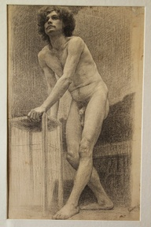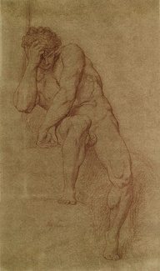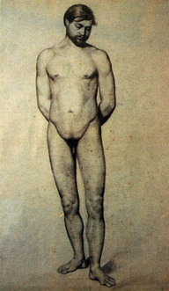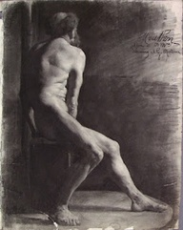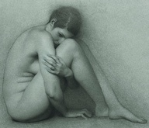
Ferenczy Cabanel Cezanne Beaux Arts Richard Morris

Week 2:
Gesture, Line, and Mass- including some 18x24” pad or better paper, possibly wc paper, using charcoal (compressed and vine), water sprayer, big hardware brushes. Competencies include line variations, structural aspects of the human form, understanding of proportional, architectural and gestural analysis, and development of familiarity with skeletal and muscular anatomy.

In-class Assignment:
Figure in Motion ( integrating marks with form, working with complex space, composing with attention towards abstract field while not losing representation, development of form with content. Materials/your choice, working with the model, defining structure and form without losing sensitivity to mark making) Multiple active poses integrated into a single composition with varied emphasis, vibrating line, echoed line - think Cebulash, Rothenberg, Degas, Guercino, Jenny Saville’s “mother and child” drawings...

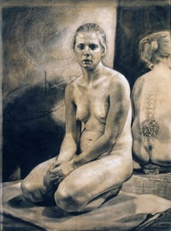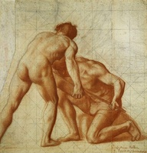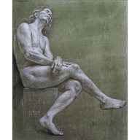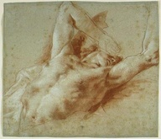
Mike Reedy Puvis de Chavannes Cadmus Rubens

Week 3:
Gesture and structure. Moving into longer poses, (charcoal, compressed and vine, water sprayer, hardware brush, white chalk or pastel, large wc paper) (mapping landmarks, composing, hatching, cross-hatching, modeling, written critique)
Extended model pose, foreshortening (understanding anatomical landmarks, working towards convincing mass, composing thoughtfully, being attentive to surface mark making, working with hatching, cross hatching and wrapped line.) Experimenting with gessoed surfaces using charcoal, you'll need your pre-gessoed sheet of paper, hardware brush, jumbo charcoal, sandpaper and clothes you don't mind getting dirty - this is both additive and subtractive. Critique.

Homework Assignment
mastercopy after Michelangelo, Prudhon, Rubens, or Da Vinci, paste photocoy on the opposite page in your journal: 1 bl & white. (1-2 hours)

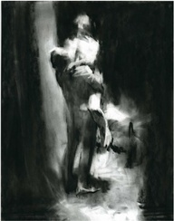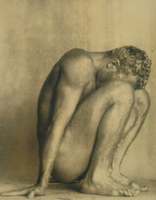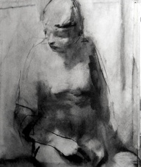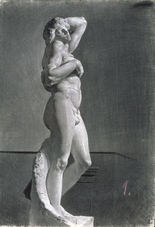
Sophie Jodoin Alvin Booth Paul Ruiz

Week 4:
Details. Study of hands and feet (gestural impact and significance of pose, placement, mark making, building of form, understanding of structure, conveyor of meaning).

Assignment: Find several images of hands and feet by masters (check pinboards), photocopy and place in journal. Work a careful rendering of hands with feet in a unified gesture on colored canson with limited color, must be well seen and felt.

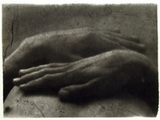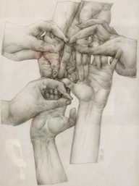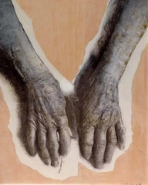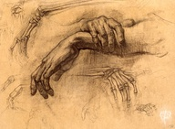
Macku Bomk Golucho
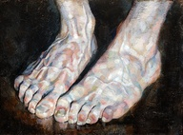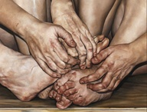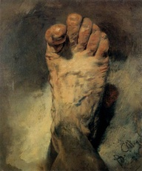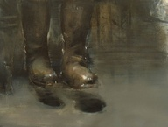
Barkley Chelsea Tyler Wood Menzel Bodoni

Week 5 and 6:

Assignment:
1) Front, side, and back of the ecorche figure in your journal
2) Begin an 18 x 24 study of the ecorche and skeletal figures composed together in space. The studies may overlap, consider viewpoint with care. Choice of charcoal with white pastel or you may use black and white conte on mid Gray paper. (3 hours)

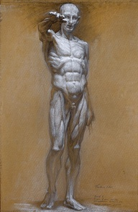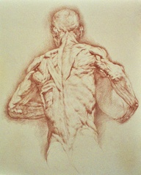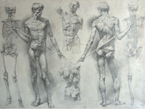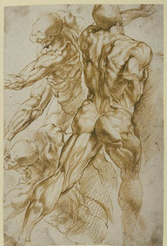
Kurt Long Alexei Novoselov Rubens

Week 7:
Subtractive/Reductive modeling (understanding of key anatomical landmarks, constructing the human form with sensitivity to boundaries, and modeling values)
Disciplined study of form using academic modeling techniques- initial subtraction of tone with eraser from pre-toned white surface, alternating with additive black charcoal and (possibly) white highlights.
Reference: Rubens, Prudhon, Mark Kang-O’Higgins, Kollwitz, da Vinci, S, Il Passignano, Sidney Goodman, Michelangelo, Savoldo, Taylor

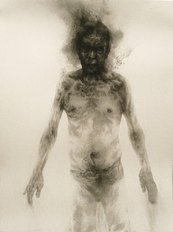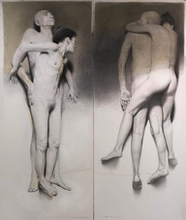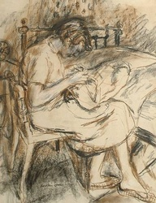
Diane Victor Golucho Ruskin Spear

Assignment: Develop a large (30 x 40" or larger) black and white self or other including hands on sanded, gessoed, charcoal covered paper (you may tone with color first) Create prepatory drawings of yourself or another, research and find artists you respond to, write down ideas, work out studies in journal, compositional possibilities etc... You are responsible for at least 5 artist sources (bring these to class) and 5 prepatory studies to be transferred to the large paper for Wednesday. The completed image is due the following Wednesday.
Bring 5 preparatory compositional drawings to class next week.

The figures should be dynamic creating a feeling of both momentum and solidity. Reference German Expressionists such as Max Beckmann and Otto Dix, and Baroque artists such as Peter Paul Rubens and Pieter Bruegel the Younger for their dynamic compositions.

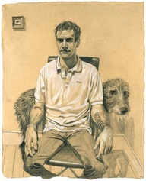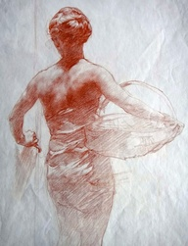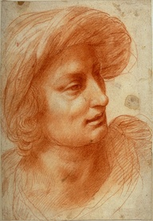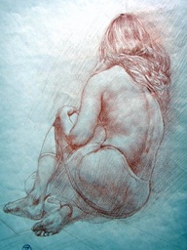
Stuart Pearson Wright Ted Seth Jacobs da Volterra Chubirko

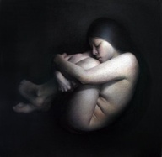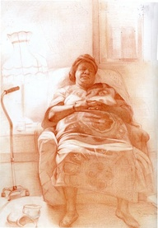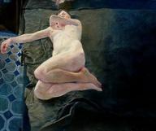
Hoshino Bredy Mathieu

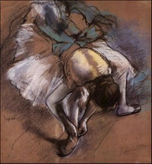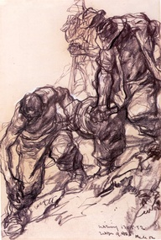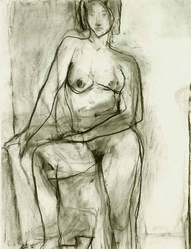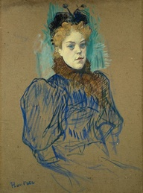
Degas Ivor Hele Diebenkorn Lautrec

Week 8:
Experimentation with limited color, figure in space (constructing the body with convincing mass, integrating seeing with markmaking to produce more felt drawings, developing critical, analytical skills, sensitivity to edge.)

Assignment: 2 color mastercopies, 1 from Lautrec, 1 from your choice. Have comps for a single full figure in setting/environment with consideration to lighting, limited color palette, continue working with mass, modeling, light, and space to create effective content.

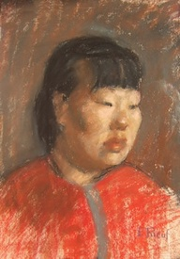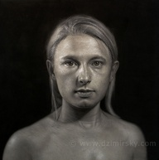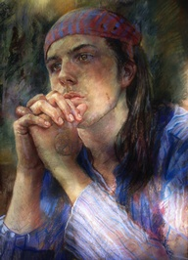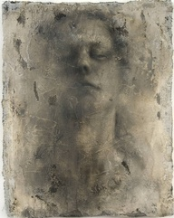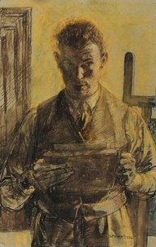
Rieuf DirkDzimirsky Penelope Miner Reiko Spear

Week 9:
Color head portrait on toned paper (inks, wc, pastels including oil pastel if you like, you may also bring clay to work with) (develpment of underlying structure, mark making, color and light sensitivity, mass and weight, personal content) Reference: Giacometti, Jerome Witkin, Edgar Jerrins, Kitaj Critique.

Assignment: Work on figure in space, due Monday.

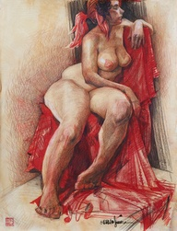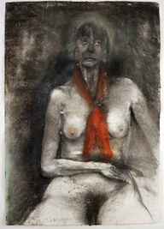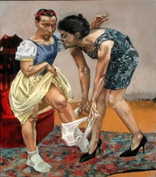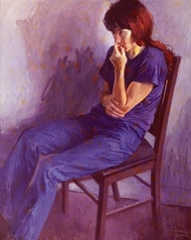
Graham Smith Jim Dine Paula Rego Soyer

Week 10:
In class, longer pose, composition and space, working with extended color palette (developing pictorial awareness, foreshortening, enhancing and understanding mass, surface, and color content)

Assignment: Review and work anatomical studies in journal. Begin 2+ figure color in space on colored, toned ground. You need artist resources, write a 1 page description of how you chose these artists as relating to your personal vision and aiding your understanding of form in space.

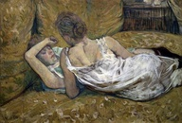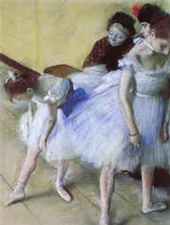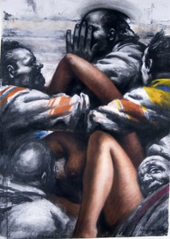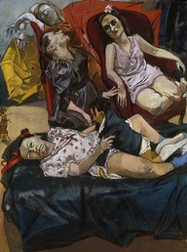

Lautrec Degas Goodman Rego

Week 11:
Continue with the model in space (developing awareness of pictorial space, foreshortening, enhancing and understanding mass, surface awareness, color sensitivity)

Assignment:
Continue with the 2+ figure in space, (write about your process in your journal and present these ideas to the group, engage the viewer with considered placement, be sure your block-in and following build up of surface and space is satisfying in scale, relationship to borders and overall effectiveness towards content. Control proportions and gestures thoughtfully. Any re-drawing, correcting of field, lighting adjustments need to go on now before the image is completed. Assess, reassess, act! Bring in for critique in process with artist resources.

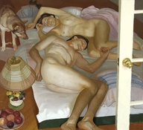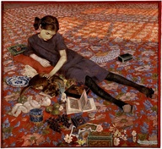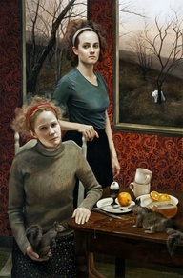
Scott Noel Casorati Kowch

Week 12:
Cropping and Surface Energy as means of creating meaning. Extended pose of the figure in environment (student self evaluation, developing critical skills, relating work historically, applying formal and conceptual skills to work in progress, pursuing ideas of scale, cropping, mass, palette, material choice, and narrative)

Assignment:
2+ figure in space (take photos in process to see changes and effects of those changes) Complete for critique. Consider abstracted, collaged version, cropping points for a mixed media small image which begins from the large piece.

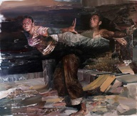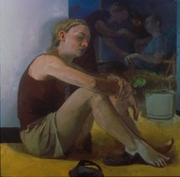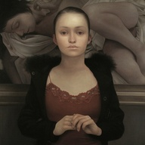
Dan Voinea Sangram Majumdar Lu Cong

Weeks 13 and 14:
Figure in environment continues (all materials), you may mix materials to further develop and carry expressive purpose. (self evaluation, seeing skills strengthened, sensitivity to materials and thoughtfulness towards total image.)

Assignment: Collaged, mixed media piece from large 2+ image plus continued journal entries (anatomical) or a small (2-10" portrait)

Final Critique.

Artists to reference:
Sigmund Abeles, Ivan Albright, Frank Auerbach, Lennart Andersen, Francis Bacon, Balthus, Jack Beal, Max Beckmann, Will Beckman, Isabel Bishop, Chuck Close, Will de Kooning, Richard Diebenkorn, Lucian Freud, Alberto Giacometti, Gregory Gillespie, Sidney Goodman, David Hockney, Hopper, Antonio Lopez Garcia, Kathe Kollwitz, Gabriel Laderman, Jacob Lawrence, Al Leslie, Matisse, Henry Moore, Ron Mueck, Alice Neel, Pearlstein, Picasso, Robert Rauschenberg, Paula Rego, Rembrandt, Rubens, Jenny Saville, Swoon, Titian, James Valerio, Vermeer, and Jerome Witkin, as a few among MANY figurative artists!!

Blog and other sites to check out:
http://www.boredpanda.com/13-hyper-realistic-sculptures-by-ron-mueck/
http://gis.net/~scatt/sketchbook/links2.html
http://www.gis.net/~scatt/sketchbook/sketchbook.html
http://www.backtoclassics.com/gallery/
http://www.saatchi-gallery.co.uk/artists/paula_rego.htm
http://www.anthonychristian.co.uk/ezine12.html
http://greggchadwick.blogspot.com/2005_03_01_archive.html
http://paintingperceptions.com/figure-painting/jerome-witkin
http://www.goodart.org/hockney.htm
http://www.drawingcenter.org/
http://www.nationalwca.org/
http://www.mattiajona.com/19thand20thcenturies.html
http://www.themorgan.org/collections/collectionsDrawings.asp
http://www.arkarts.com/collection/drawing_collection
http://www.moma.org/explore/collection/drawings
http://www.courtauld.ac.uk/gallery/collections/drawingsprints/highlights.shtml
http://collectionsonline.lacma.org/mweb/about/prints_about.asp
http://www.ogl.cz/en/exhibitions.php
www.arthermitage.org/Chinese-Art-and-Culture-2-000-BC-20th-century.html
http://www.virginia.edu/artmuseum/collections_NEW/the_collections/Prints_Drawings/index.php
http://www.staedelmuseum.de/sm/index.php?StoryID=249
http://www.artic.edu/aic/collections/prints
http://www.nga.gov/collection/gallery/rembrandt/rembrandt-main1.html

